CHEMICAL ENGINEERING TRANSACTIONS  VOL. 93, 2022 | A publication of
The Italian Association
of Chemical Engineering
Online at www.cetjournal.it

Guest Editors: Marco Bravi, Alberto Brucato, Antonio Marzocchella
Copyright © 2022, AIDIC Servizi S.r.l.
ISBN 978-88-95608-91-4; ISSN 2283-9216

Incorporation Of A Filter Media By Cellulose Fibers In Biosafety From Sugarcane Bagasse By Alkaline Hydrolysis
Paula G. Fonseca, Juan F. Monroy, Diana M. Morales, Juan C. Cely
Department of Chemical engineering Fundación Universidad América, Bogotá, Colombia
juan.cely@profesores.uamerica.edu.co
The pandemic caused by COVID-19 has generated an increase in the consumption of personal protective equipment focused on reducing the risk of contagion and respiratory affectations, being the masks the fundamental article to combat the spread according to the World Health Organization, where the surgical mask is the most used worldwide, made entirely of polypropylene, taking 400 years to disintegrate being 90% of these masks end their useful life in streets, landfills or even in the ocean. To decrease contamination sugarcane bagasse due to its availability and percentage of cellulose has important characteristics to be used as a biodegradable filter media as the first step to incorporate it into a cloth mask. Three cellulose extraction methodologies were stipulated based on acid hydrolysis using H₂SO₄ and alkaline hydrolysis using NaOH, in acid routes there is a rupture of the β 1- 4 glycosidic bonds generating glucose affecting the % of cellulose, giving reason to the use of alkaline hydrolysis at 5% w/v with a yield of 32.00 %, 80.39 % in its extraction and taking advantage of the black liquor generated in the alkaline hydrolysis towards cogeneration. Finally, as the filter media is an organic nonwoven, its disintegration time is shorter compared to the polypropylene nonwoven, evidenced in a qualitative study of vermicomposting by implementing Californian earthworm, governed by EN-13432, with 18°C, moisture above 50%, pH of roughly 9 and a C/N ratio of 25:1 are taken into account, resulting in a total disintegration of the filter media in 26 days compared with dry leaves, both sources of carbon.
  - Introduction
In Colombia, sugarcane is the second-largest crop, where 25% belongs to sugar mills and the remaining 75% to farmers in different areas of the country with a total of 241,205 hectares(Cueva-Orjuela et al., 2017). Sugarcane bagasse is the agro-industrial waste generated when is extracting the juice (Aguilar Rivera, 2011), consisting of cellulose at 41.05% w/w, hemicellulose at 37.4% w/w, and lignin at 21.55% w/w (Velandia, 2017). Consequently, 83% of this is used for cogeneration of energy by burning in boilers (Cueva-Orjuela et al., 2017), the remaining being applied to various extraction processes for lignocellulosic compounds, where it is estimated that for each ton of sugarcane bagasse 170 kg of cellulose is obtained (Ross-Alcudia et al., 2017). we drilled down into the chemical method due to its worldwide use. On the other hand, the pandemic caused by the SARS-CoV-2 virus known as COVID-19 has generated an increase in the consumption of facemask that is only is using once, after that is a plastic waste which is not biodegradable material and induces further climate change pollution by affecting land and groundwater(Selvaranjan et al., 2021). Recently, the interest in giving an added value to agroindustrial wastes has become more relevant due to their good properties. Therefore, the objective of this study was to evaluate the obtaining of cellulose from sugarcane bagasse according to the hydrolysis used and to determine the degradation time of approximately 1 gram in vermicomposting.

  - Sugarcane bagasse scope
The sugarcane bagasse was mainly evaluated with three extraction methodologies to determine the one with the best results according to its percentage of cellulose and yield of the raw material used; for the development, the operating conditions were taken into account by (Bassante, 2018), (Montañez & Moreno, 2019) and (Garcia Alcocer et al., 2019) acco,rding to their percentages of lignocellulosic compounds close to the sugarcane bagasse, extracted by acid and alkaline hydrolysis, as shown in Table 1
Table 1: Hydrolysis Routes
Route | Process
I | H₂SO₄ 0,4 % v/v + NaOH 5 % w/v
II | H₂SO₄ 1 % v/v + NaOH 5 % w/v
III | NaOH 5 % w/v

    - Sugarcane bagasse pretreatment
Bagasse from sugarcane of the "Saccharum officinarum" specie, known as "caña criolla" (Triana et al., 1990) was obtained after removing the juice from the sugarcane, this removal was done by passing the cane 3 to 4 times through a mill, followed by drying bagasse for 40 to 48 hours at room temperature, seeking to inhibit microbial growth by preventing the degradation of lignocellulosic compounds, this because of the approximate 50% moisture with which it leaves, forming a rich substrate capable of allowing microbial growth (Olmo et al., 2018), After the drying time, the remaining medulla (parenchymatous tissue) was separated from the fiber, avoiding the increase in the use of reagents because this is the container of the juice in the cane. Finally, its size was reduced to obtain a larger contact surface and sieving, to obtain the adequate size for hydrolysis, which was from 0.7 mm to 1.8 mm obtained in the 20 mesh according to ASTM standards because the 10, 20 and 40 sieves were used.
    - Hydrolysis routes
The cane bagasse fiber was treated in the route I with 13 grams of 20 mesh, using water as solvent. This solution was manually agitated maintaining a range of 50 °C for one hour, then it was washed with water in excess to neutralize the pulp and was left to dry for 24 hours at 50°C. Once the pulp was dry, the alkaline hydrolysis was carried out using NaOH 5 % w/v, with constant agitation and following the same steps of the previous hydrolysis, taking into account the temperature of 70 °C in this case.

Route II was carried out in the same way as the previous one, changing the concentration of the acid hydrolysis to 1% v/v. These changes in concentration are associated with obtaining fermentable sugars from lignocellulosic compounds, in which the acid hydrolysis must be diluted to avoid the denaturation of the compound, allowing its main use in the production of bioethanol thanks to the solubility of hemicellulose and lignin. (Chandler et al., 2012)

Finally, route III was carried out by performing the alkaline hydrolysis based on the same concentration contemplated in the route I and II, which is very similar to the Kraft process. After the chemical process routes were carried out, the pulp was dried to obtain a filter media of approximately 1 gram, as can be seen in Figure 1.
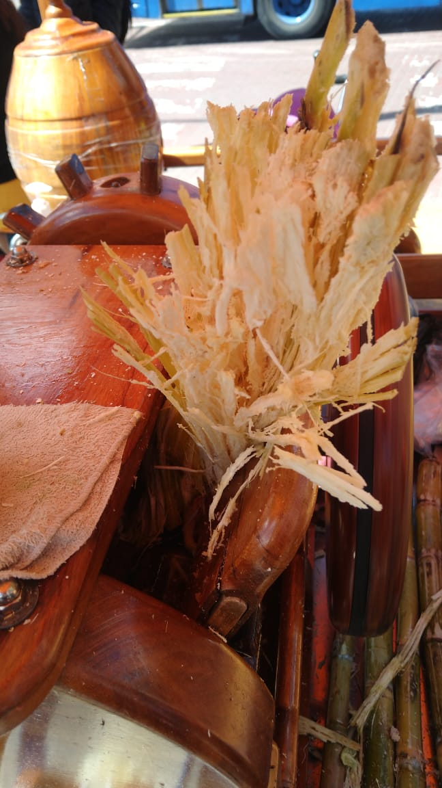
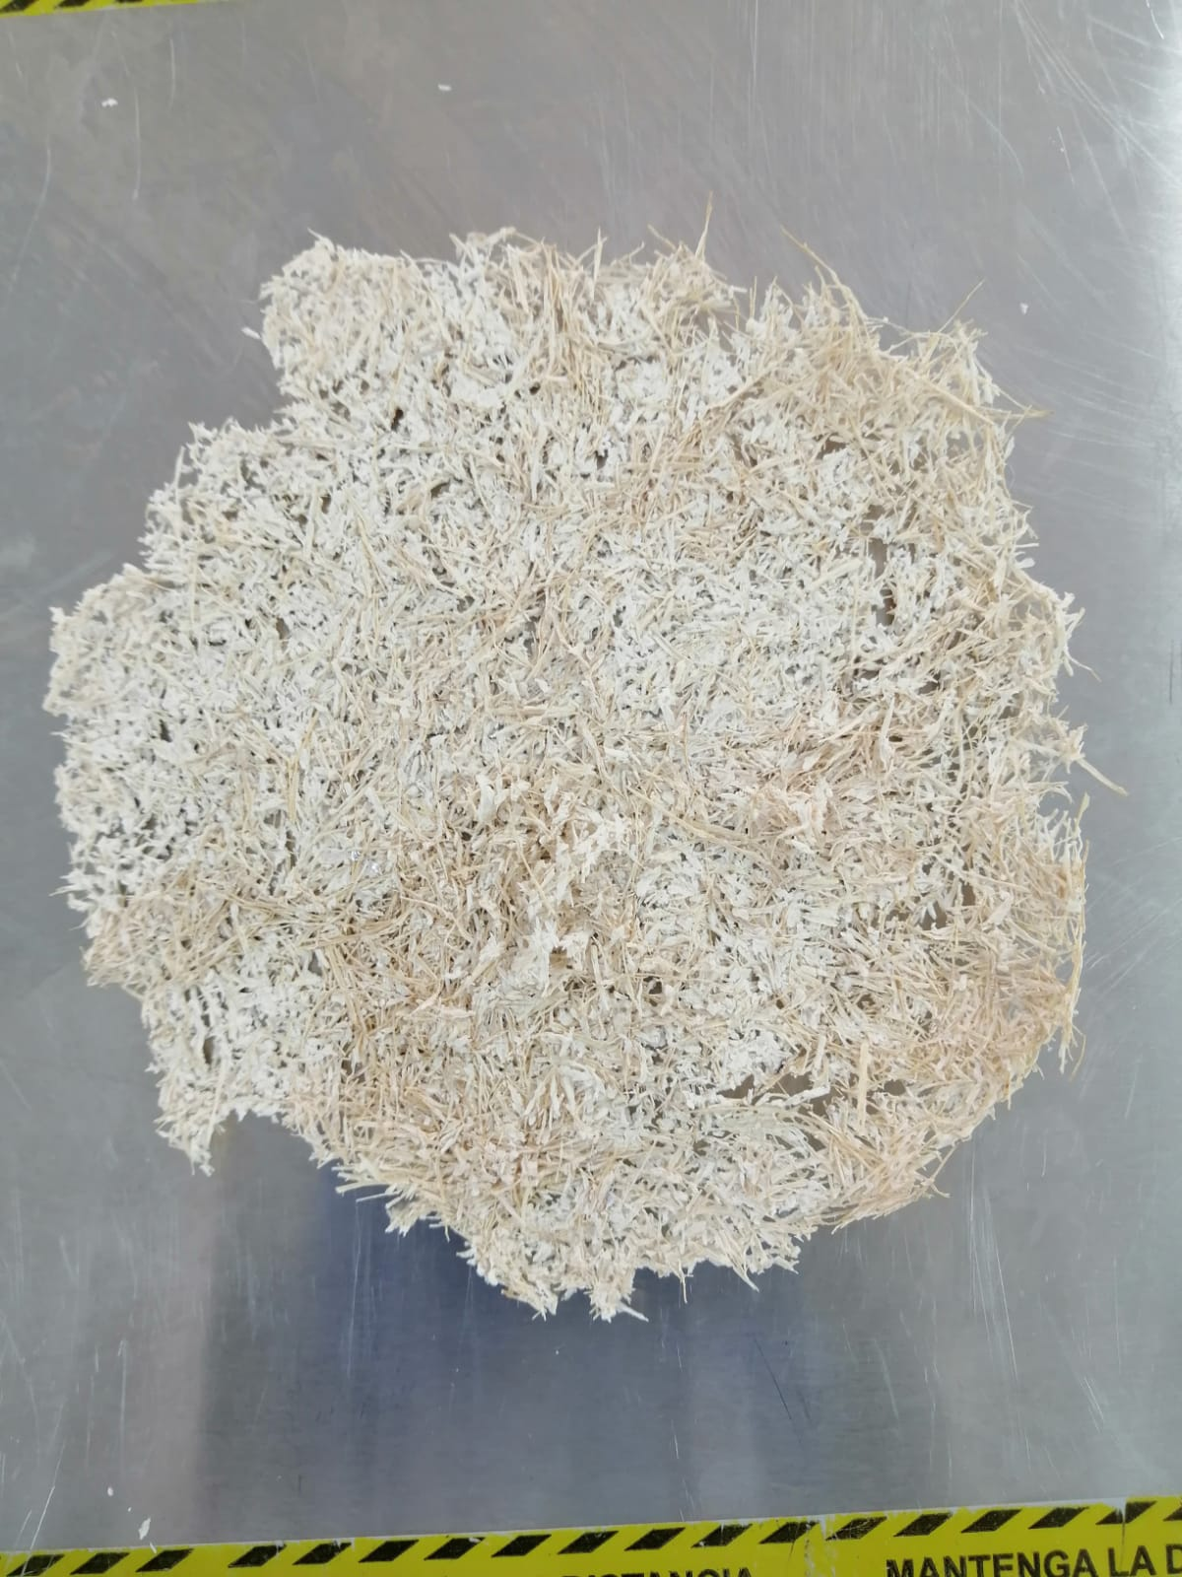
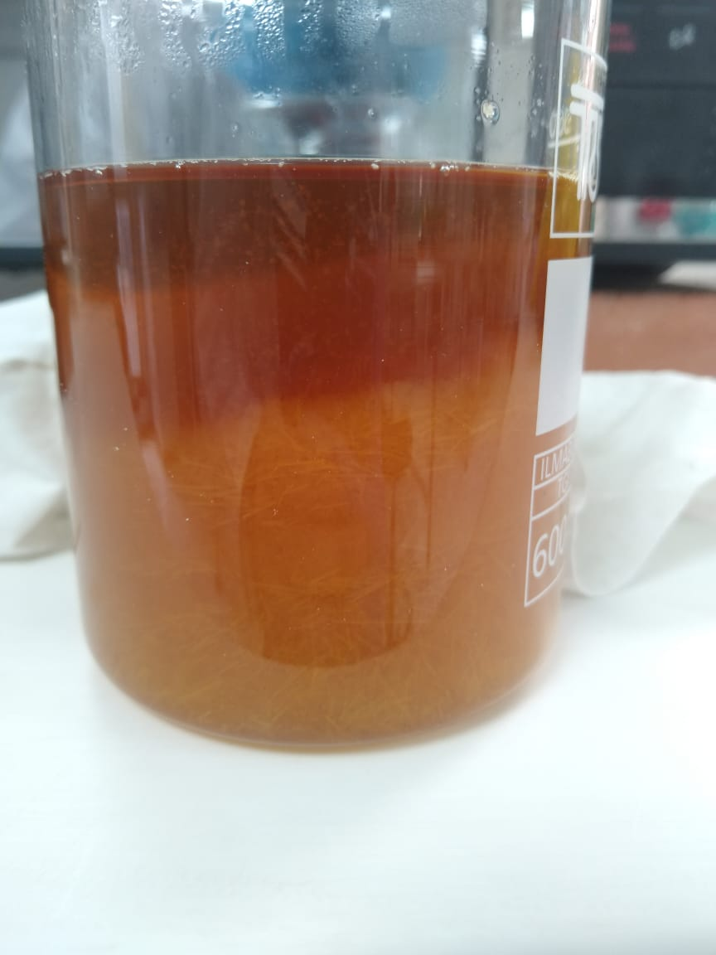

Figure 1 Sorting and extraction of cellulose fibers
    - Method of analysis
Due to the previously indicated routes, the quantification of cellulose percentage was carried out, being the most abundant renewable biomass present in the cell wall (Ngo et al., 2021), This was carried out at reflux with a constant temperature of 70 - 75ºC for 20 minutes where 1 gram of sample (Pm) is put in contact with a solution of concentrated HNO₃ and CH₃COOH at 80 % v/v. Then, it was washed with ethanol, left for 20 minutes in the muffle at a temperature range of 140ºC-160ºC, and passed 15 minutes to the desiccator obtaining P_{A}, this value was incinerated for 30 minutes at 520ºC-560ºC, weighing again after 15 minutes in the desiccator obtaining P_{B}.
$$Cellulose percentage (\%)=\frac{\left(P_{A}\right)-\left(P_{B}\right)}{P_{m}}*100$$ | (1)
Following the cellulose quantification, the lignin determination was carried out to obtain a low percentage that allows the connection of the fibers, looking for the homogeneity of the filter media, together with slight microbial protection, This methodology was performed by weighing 1 gram of sample (Pm) and according to adjustments to the Klason method standardized according to ASTM D 1106-96, starting by putting the pulp in contact initially with H₂SO₄ at 72% v/v for 2 hours, in which the carbohydrates are hydrolyzed and solubilized by the acid. (Adell & Mocchiutti, 2008). To change from polysaccharides to oligosaccharides, the concentration was then reduced to 5% v/v in which the oligosaccharides were broken down into monosaccharides. (Romero et al., 2014). then filtered to obtain the residue for drying using a muffle at 105 °C and 15 minutes obtaining the P_{C} and finally, the temperature was raised to 540 °C for 15 minutes obtaining P_{D} (Domínguez-Domínguez et al., 2012)
$$lignin percenage (\%)=\frac{\left(P_{C}\right)-\left(P_{D}\right)}{P_{m}}*100$$ | (2)
    - Compostability test
To evaluate the feasibility of applying the filter media for composting, an ecosystem focused on vermicomposting, in which the filter media is a substrate rich in carbon, generated a distribution by layers ( table 2), where the influence of the Californian earthworm is evaluated; for the adaptation of the filter media from sugarcane bagasse, in which the evaluation of parameters such as pH, moisture and temperature was carried out for 4 weeks, having the filter media as the main substratum. Additionally, a carbon and nitrogen ratio (C/N) between 25:1 w/w was implemented. (Román, Pilar, Martinez, Maria, 2015) using eggshells around the filter media.
Table 2. Weights of layers used by triplicate in vermicomposting
First Layer  Ground (g) | Second Layer  Humus (g) | Third Layer  Worms (g) | Fourth Layer  Ground (g) | Fifth Layer  Filter Media (g) Eggshell(g) |  |  | Sixth Layer  Ground (g)
100.70 | 50.40 | 2.67 | 31.20 |  | 1.09 | 1.01 | 81.10
  - Results and discussion
The result regarding the route of extraction by both alkaline and acid hydrolysis can be seen in Figure 2, being cellulose the major constituent in the pulp to be implemented, focused on the use in masks such as N95. On the other hand, as sugarcane bagasse is a soft fiber, it has a high content of cellulose. (Montañez & Moreno, 2019) requires low concentrations in the established processes shown in Table 1. Thus, the yield is directly associated with the percentage of cellulose extraction, since it is not higher than 60%. (Carpio et al., 2020) due to the solubilization of the fibers in the type of treatment, looking for a benefit in both variables along with a beneficial degradation time.

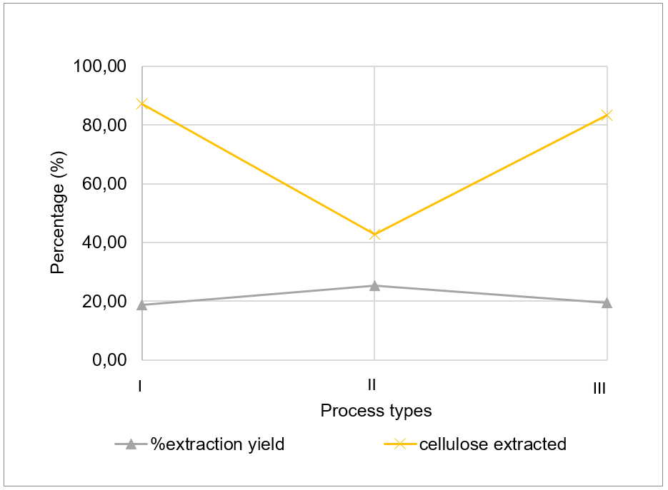

Routes

Figure 2. Percentage of extraction and extraction yield concerning the type of hydrolysis evaluated.

Once route III was established as the best procedure, due to its extraction of 78.95% cellulose and a yield of 32.1%. From which a black liquor is generated, currently used as an energy cogenerator, since it has lignocellulosic components, it means soluble lignin, hemicellulose, and solubilized cellulose. As a filter media applied in biosafety, was taking into account the neutrality of the fibers as they come into contact with the user and seeking to avoid irritation or damage to the skin.
Table 3. Lignin remaining and cellulose extraction in cellulose fibers by sugarcane bagasse.

# Alkaline replica | Lignin percentage (%) | Cellulose percentage (%)
1 | 3.98 | 83.23
2 | 1.72 | 80.39
3 | 2.26 | 79.95

Although a percentage of 1.39 % ± 1.18 % is found, it also provides benefits to the filter media due to its structure, which retards the penetration of microorganisms to the lignocellulosic compound, preventing degradation of the lignocellulose (Negro et al., 1990). However, it provides flexural strength that was later solved with a group of additives since it is not significant.

Based on these 2 key variables in contrast to the search to reduce the use of polypropylene masks, sugarcane bagasse fibers are an alternative since it is an organic element and its components can degrade, compost, or be modified to benefit the environment, generating a positive impact for its final disposal and/or processes after its use as a filter media, for that reason, 1.09 ± 0.09 grams of final filter media sheet is exposed to vermicomposting where the Californian earthworm is used, in this case, 10 of them with a weight of 2.67± 0.17 g, in 3 trials in addition to the white one, being dry leaves. Where, there is a distribution to reach the substratum, in this case, the cellulose fibers without affecting their growth, as shown in figure 3.

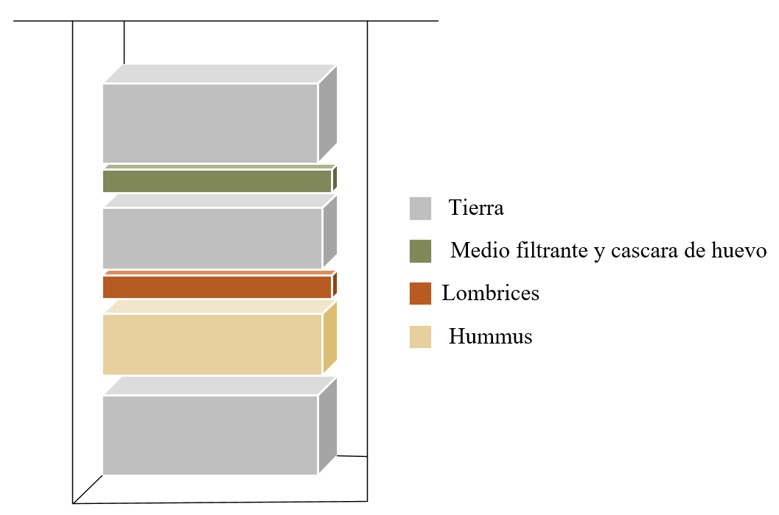
HUMUS

WORMS

FILTER MEDIA AND EGGSHELLS

GROUND

Figure 3. Layers in vermicomposting.
It also is noted that both the filter and the dry leaves should be checked periodically for pH since they require soils with free calcium ions to maintain a higher pH in their blood, avoiding acidic soils. (Román, Pilar, Martinez, Maria, 2015), moisture and temperature, are directly linked to these variables, since to conserve the population, contact with light and high temperatures must be avoided, being below 35ºC with moisture above 50%. (Departamento Nacional de Planeación, 2016), as shown in the table below.
Table 4. Average regulated conditions in vermicomposting.
Parameters | Filter Media | Dry leaves
pH | 9.23±0.12 | 9.26±0.14
% Moisture | 60.43±0.02 | 60.3±0.03
Temperature (°C) | 18.75±1.65 | 18.75±1.7

Based on a process evaluated from the change over time, a qualitative analysis is developed, where being a hygroscopic material, it benefits the compostability process by being easily digested by the worms since they do not have teeth, and on the other hand, since cellulose is a carbon source, giving reason to the addition of eggshell to generate an appropriate C/N ratio. (Sherman, 2018).

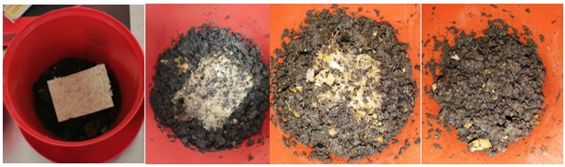
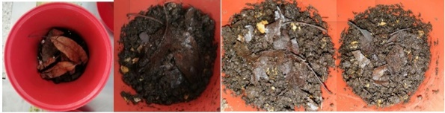
Figure 4. Filter media in vermicomposting; dry leaves in vermicomposting.

Finally, in 26 days, the filter media was totally transformed into organic fertilizer when digested and transformed by the enzymes of the earthworms and 60% excreted. (Mikolic et al., 2018), providing a new sustainable product. The opposite is the case with dry leaves because their stalk does not disappear since it is not feasible for feeding due to its rigidity.
  - Conclusions
When routes I and II are carried out, a strong difference is evidenced by changing the H₂SO₄ concentration by 0.6%, which confirms the breaking of the glycosidic bonds present, generating glucose. On the other hand, the percentage of cellulose from route III presents greater ease of replication and allows obtaining a pulp with less lignin content due to the rupture of the ether bonds of the lignin using the OH free radicals of the sodium hydroxide, obtaining a low percentage of lignin that offers the connection of cellulose pulp and mild antimicrobial protection. In addition, being a hygroscopic material, it benefits the digestion of the worms by being a food of interest. Therefore, after 26 days, no remaining fibers are observed.
Acknowledgments
To all the people involved in the Fundación Universidad America and the Tecnoparque SENA nodo Bogota for their constant support to develop this research.
References
Adell, A. M., & Mocchiutti, P. (2008). Fundamentos De La Producción De Pastas Celulosicas. Journal of the Institute of Brewing, 85(2), 58–63.
Aguilar Rivera, N. (2011). Efecto del almacenamiento de bagazo de caña en las propiedades físicas de celulosa grado papel Effect of Storing of Sugar Cane Bagasse on Physical Properties from Cellulose for Paper. Ingenieria investigacion y tecnología, XII, 189–197.
Bassante, J. C. B. (2018). Evaluación de diferentes pretratamientos químicos a la biomasa de la cáscara de cacao para procesos de fermentación alcohólica. https://repositorio.usfq.edu.ec/bitstream/23000/8423/1/139537.pdf?dLDf=false
Carpio, K., Daga, M., Huaman, D., Galletti, M., & Zapata, C. (2020). Producción y comercialización de mascarillas biodegradables a base de almidón de yuca. http://repositorio.usil.edu.pe/bitstream/USIL/10246/3/2020_Escobar Carpio.pdf
Chandler, C., Villalobos, N., González, E., Arenas, E., Mármol, Z., Mazzarri, J. R., & Aiello, C. (2012). Hidrólisis ácida diluida en dos etapas de bagazo de caña de azúcar para la producción de azúcares fermentables. Multiciencias, 12(3), 245–253.
Cueva-Orjuela, J. C., Hormaza-Anaguano, A., & Merino-Restrepo, A. (2017). Sugarcane bagasse and its potential use for the textile effluent treatment. Dyna, 84(203), 291–297. https://doi.org/http://dx.doi.org/10.15446/dyna.v84n203.61723
Departamento Nacional de Planeación. (2016). Documento CONPES 3874. Politica Nacional Para La Gestión Integral De Residuos Solidos. Consejo Nacional de Política Económica y Social República De Colombia.Departamento Nacional De Planeación (DNP), 1–73. https://colaboracion.dnp.gov.co/CDT/Conpes/Económicos/3874.pdf
Domínguez-Domínguez, M. M., Álvarez-Castillo, A., Granados-Baeza, M., & Hernández-Campos, F. (2012). Estudio de la cinética del pretatramiento e hidrólisis ácida del bagazo de caña de azúcar. Iberoamericana de Polimeros, 13(4), 200–211.
Garcia Alcocer, N. K., Salgado García, S., Cordoba Sanchez, S., Castañeda Ceja, R., De la Cruz Burelo, P., & Turrado Saucedo, J. (2019). Evaluation of calcium oxide and calcium hydroxide for the obtaining of cellulose fiber. 12, 3–9. https://doi.org/10.32854/agrop.v0i0.1433%0AEvaluation
Mikolic, C., Andreoni, I., Ruffinelli, S., Gómez, A., Dárdano, B., Basile, D., & Jorge Escudero, G. (2018). Manual De Vermicompostaje: Cómo reciclar nuestros residuos orgánicos. Montevideo Ambiente, 1, 1–208. https://montevideo.gub.uy/sites/default/files/biblioteca/imvermicompostajeinterior.pdf
Montañez, J. A. M., & Moreno, D. A. Z. (2019). Evaluación de la obtención de celulosa partiendo del buchón de agua (eichhornia crassipes) mediante la hidrolisis básica y el proceso enzimático del hongo pleurotus ostreatus. https://repository.uamerica.edu.co/bitstream/20.500.11839/7605/1/6132185-2019-2-IQ.pdf
Negro, M. J., Martínez, J. M., Manero, J., Sáez, F., & Martín, C. (1990). Efecto del pretratamiento con explosión por vapor en la hidrólisis enzimatica de madera de eucalipto y bagazo de sorgo (p. 40).
Ngo, P., Vi, H., Diep, N., & Vinh, T. (2021). Cellulose Degrading Ability of Bacterial Strains Isolated from Gut of Termites in Vinhlong Province - Vietnam. 88(July), 1315–1320. https://doi.org/10.3303/CET2188219
Olmo, O. A. del, Aracelia Hernández Gutiérrez, Herrada, M. A. B., Cabo, O. C., Polo, G. N. A., & Rodríguez, N. F. (2018). El bagazo de la caña de azúcar. Propiedades, constitución y potencial. https://docplayer.es/72041168-Parte-v-el-bagazo-de-la-cana-de-azucar-propiedades-constitucion-y-potencial.html
Román, Pilar, Martinez, Maria, P. (2015). Manual de compostaje del agricultor. En Oficina Regional de la FAO para América Latina y el Caribe. http://www.fao.org/3/a-i3388s.pdf
Romero, E., Montero, G., Toscano, Pérez, L., Torres, R., & Beleño, M. T. (2014). Determinación de los principales componentes de la biomasa ligonocelulósica; celulosa, hemicelulosa y lignina de la paja de trigo para su posterior pretratamiento biológico. XVII Congreso Internacional de Ciencias Agricolas, October, 114–118. https://www.researchgate.net/publication/282365664
Ross-Alcudia, R. E., Bolio-López, G. I., Veleva, L., Azamar-Barrios, J. A., Hernández-Villegas, M. M., Pérez-Romero, J., Pérez-Romero, C. A., Correa-Durán, M. S., & Córdova-Sánchez, S. (2017). Planta piloto para obtención de celulosa de residuos de caña de azúcar (Saccharum spp.) y elaboración de recipientes biodegradables. Agroproductividad, 10(11), 60–65. https://revista-agroproductividad.org/index.php/agroproductividad/article/view/64/59
Selvaranjan, K., Navaratnam, S., Rajeev, P., & Ravintherakumaran, N. (2021). Environmental challenges induced by extensive use of face masks during COVID-19: A review and potential solutions. Environmental Challenges, 3(February), 100039. https://doi.org/10.1016/j.envc.2021.100039
Sherman, R. (2018). The worm farmer’s handbook. Chelsea Green Publishing.
Triana, O., Leonard, M., Saavedr, F., Fernandez, N., Galvez, G., & Pena, E. (1990). Atlas of sugarcane bagasse. https://digitalcollections.qut.edu.au/1529/1/Atlas_of_Sugarcane_Bagasse.pdf
Velandia, A. E. C. (2017). Adsorbentes naturales en la mitigación del impacto adverso causado por derrames de crudo en fuentes hídricas. Hilos Tensados, 1, 1–476.

